

##### E-Commerce website using PHP

**Minor Project and Viva-voce (MCAN-381)**

##### In

**Master of Computer Applications**

**Saptangshu Ghosh (14871022041)**

## Roop Paul (14871022036)

## Pritam Sarkar (14871022057)

## Abhijit Haldar (14871022039)

## Abhijit Das (14871022047)

# Under the guidance of

# Prof. Shreyasi Bhattacharya

## FUTURE INSTITUTE OF ENGINEERING AND MANAGEMENT

**(Affiliated to Maulana Abul Kalam Azad University of Technology, West Bengal Formerly Known as West Bengal University of Technology)**

# KOLKATA 700 150

**2023**



FUTURE INSTITUTE OF ENGINEERING AND MANAGEMENT

Sonarpur Station Road, Kolkata – 700150

MCA-DEPT

CERTIFICATE FOR PROJECT WORK

We do hereby certifying that the work which is being presented in the Minor Project Report entitled **“E-Commerce website”,** in partial fulfillment of the requirements for the award of Master of Computer Applications submitted to the MCA-Dept. of **Future Institute of Engineering and Management, Kolkata, WB** is an authentic record of our own work carried out during the period from 21/08/2023 to 22/11/2023 under the supervision of **Prof. Shreyasi Bhattacharya**.

The matter presented in this thesis has not been submitted by us for the award of any other degree elsewhere.

*Name* & *Signature of the Candidate(s)*

**a)**

**b)**

**c)**

**d)**

**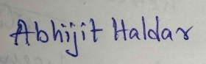 e)**

This is to certify that the above statement made by the students, is correct to the best of my knowledge.

*Signature of the Supervisor*

**Date: Prof. Shreyasi Bhattacharya**

**Head *Signature of the External Examiner***

**CA-Dept. *& Panel Members***

**Future Institute of Engineering and Management Kolkata, WB**

**TABLE OF CONTENTS**

|  |  |
| --- | --- |
| **TITLE** | **PAGE NO** |
| **INNER TITLE PAGE** | 1 |
| **CERTIFICATE FROM SUPERVISOR** | 2 |
| **CERTIFICATE OF PANEL MEMBERS** |  |
| **1 ABSTRACT** | 4 |
| **2 INTRODUCTION** | 5 |
| **2.1 RELEVANCE OF THE TOPIC** | 5 |
| **2.2 PROBLEM DEFINITION** | 6 |
| **2.3 PROJECT OBJECTIVE** | 6 |
| **3 METHODOLOGY** | 6 |
| **4 SYSTEM ANALYSIS** | 7 |
| **4.1 FEASIBILITY** | 7 |
| **4.2 PROPOSED SYSTEM** | 8 |
| **4.3 DATA FLOW DIAGRAM** | 9 |
| **4.4 USE CASE DIAGRAM** | 11 |
| **4.5 SOFTWARE REQUIREMENTS** | 11 |
| **4.5.1 FRONT END** | 11 |
| **4.5.2 MIDDLE END** | 12 |
| **4.5.3 DATABASE SERVER** | 12 |
| **4.6 HARDWARE REQUIREMENTS** | 13 |
| **5 SYSTEM DESIGN** | 13 |
| **5.1HOME PAGE** | 14 |
| **5.2 LINKS AND WEB PAGES** | 15 |
| **6 CODING** | 18 |
| **6.1 FEATURES OF LANGUAGE** | 18 |
| **6.2 CODING** | 19 |
| **7 EXPERIMENTAL RESULTS** | 31 |
| **8 FUTURE SCOPES** | 32 |
| **9 CONCLUSION** | 33 |
| **10 ACKNOWLEDGEMENT** | 34 |
| **11 REFERENCES/BIBLIOGRAPHY** | 35 |

# ABSTRACT

In this paper we are going to build an e-commerce website. This project deals with

developing an e-commerce website for Online Product Sale. The objective of this

project is to develop a general purpose e-commerce store where different kinds of

electronic product can be brought from the comfort of home through Internet. Online shopping in India is getting a noticeable growth as more usage of internet facilities, high educational standards, changing life style and economic growth of the country reasons in the demand of e-commerce techniques and tools. Versatile shopping experience and rapid development of transaction facilities is further boosting opportunities for the market segments. The biggest advantage of e-commerce is the ability to provide secure shopping transactions via the internet. One of the most important issues to be addressed in electronic commerce is the area of service

# 2. INTRODUCTION

# E-Commerce, also known as electronic commerce or internet commerce, is an activity of buying and selling goods or services over the internet or open networks. So, any kind of transaction (whether money, funds, or data) is considered as E-commerce. So, E-commerce

# can be defined in many ways, some define E-Commerce as buying and selling goods and services over the Internet, others define E-Commerce as retail sales to consumers for which

# the transaction takes place on open networks. The buying and selling of products, services, and digital products through the Internet all fall under the umbrella of e-commerce.

**2.1. RELEVANCE OF THE TOPIC**

E-commerce is the application of information technology and communication technology to three basic activities related to commercial business, the three basic activities are as follows:

1. Production and support- It includes production, distribution, and maintenance of goods .

and services.

1. Transaction preparation- It includes getting product information from the market-place

and bringing buyers and sellers into contract with each other and

1. Transaction completion- It includes concluding transactions, transferring payments, and securing financial services.

**2.2 PROBLEM DEFINITION**

The Internet has become a major resource in modern business, thus electronic shopping has gained significance not only from the entrepreneur's but also from the customer's point of view. For the entrepreneur, electronic shopping generates new business opportunities and for the customer, it

makes comparative shopping possible.

As per a survey, most consumers of online stores are impulsive and usually make a decision to stay

on a site within the first few seconds. "Website design is like a shop interior. If the shop looks poor

or like hundreds of other shops the customer is most likely to skip to the other site.

Hence we have designed the project to provide the user with easy navigation, retrieval of data

and necessary feedback as much as possible. In this project, the user is provided with an

e-commerce web site that can be used to buy all types of products online.

# 2.3. PROJECT OBJECTIVE

# The business-to-consumer aspect of product commerce (e-commerce) is the most visible business use of the World Wide Web. The primary goal of an e-commerce site is to sell goods online. This project deals with developing an e-commerce website for Online Product Sale. The objective of this project is to develop a general purpose e-commerce store where different kinds of

# product can be brought from the comfort of home through Internet.

# 3. METHODOLOGY

In this project we have an e-commerce website using various software tools, scripting and markup languages. Here's how these tools are used in the context of our project:

Software:

1. Visual Studio Code: An integrated development environment (IDE) that provides a code editor with features

like syntax highlighting, code completion, and debugging capabilities. We can use Visual Studio Code

as our primary code editor for developing the frontend and backend components of our application

1. Sublime Text: Sublime Text 3 (ST3) is a lightweight, cross-platform code editor known for its speed, ease

of use, and strong community support. It's an incredible editor right out of the box, but the real power comes from the ability to enhance its functionality using Package Control and creating custom settings.

1. XAMPP Control Panel: XAMPP provides a Control Panel for efficient management of the software in the XAMPP package. You can use the Control Panel to determine whether Apache and MySQL are currently running and to start or stop them. Before you can use your development environment, Apache and MySQL

must be running.

Scripting Language:

1. PHP: PHP (recursive acronym for PHP: Hypertext Preprocessor ) is a widely-used open source

general-purpose scripting language that is especially suited for web development and can be

embedded into HTML.

1. Java Script: JavaScript is a scripting language used to create and control dynamic website content, i.e. anything that moves, refreshes, or otherwise changes on your screen without requiring you to manually reload a web page. Features like: animated graphics. photo slideshows.

Icons:

1. Font Awesome: A comprehensive library of scalable vector icons that can be customized and easily

integrated into our application's user interface. Font Awesome offers a wide range of icons that can

be used for chat-related functionalities or UI elements.

1. Bootstrap Icons: A collection of open-source icons designed to work seamlessly with the

Bootstrap framework. We can use Bootstrap Icons to enhance the visual appeal of your application's UI components, including buttons, navigation elements,

and more.

By using these software tools, markup and scripting language’s we can develop a robust e-commerce application.

# 4. SYSTEM ANALYSIS

Here in this project, we have a website interface and a Database.

So, we have Data Flow Diagram, Use Case Diagram, Software and module.

# 4.1 Feasibility

Whenever a new system (a hardware or software) is to be introduced, there is a need to study the new system in every aspect or manner before working on it. We get the idea whether the project is adequate or not.

TECHNICAL FEASIBILITY-

1. The necessary technology exists to do what is suggested.
2. The team is competent in that.
3. The technology is also available and the capacity is also sufficient.

OPERATIONAL FEASIBILITY-

1. There is sufficient support for the project from the management.
2. Proper planning and development of the project is being done.
3. The upcoming project will also reduce the hardships encountered and is considered to be operationally feasible.

ECONOMIC FEASIBILITY-

The application can be developed within budget.

# 4.2. Proposed System

In this project we first land on to the home page. Upon landing on the website, users are greeted with an engaging homepage displaying featured products, promotions, or categories.

Login/Register:

Users can either log in using their existing credentials or register for a new account to access additional features like order tracking, saved carts, and personalized recommendations.

Navigation/Search Items:

The navigation bar or search bar allows users to explore products by categories, brands, or keywords.

Filters and sorting options assist in refining search results based on price, popularity, or other attributes.

Select Items:

User’s browse through the available products, click on individual items to view detailed descriptions, images, prices, and add them to their selection.

Add or Remove Items into Cart:

A visible shopping cart icon allows users to view their selected items, make quantity adjustments, and remove items if needed.

Proceed to Payment:

When ready to purchase, users proceed to the checkout or payment page where they confirm their selected items, input shipping details, and choose a preferred payment method.

This sequence of steps ensures a smooth user journey, enabling customers to easily navigate the website, find desired items, manage their selections, and complete the purchase securely. Integration of a user-friendly interface, secure payment gateways, and clear navigation aids in enhancing the overall shopping experience

**4.3. Data Flow Diagram**

|  |
| --- |
| **DFD Level 0**  **C:\Users\SAPTANGSHU\Downloads\0.1_level.PNG** |

**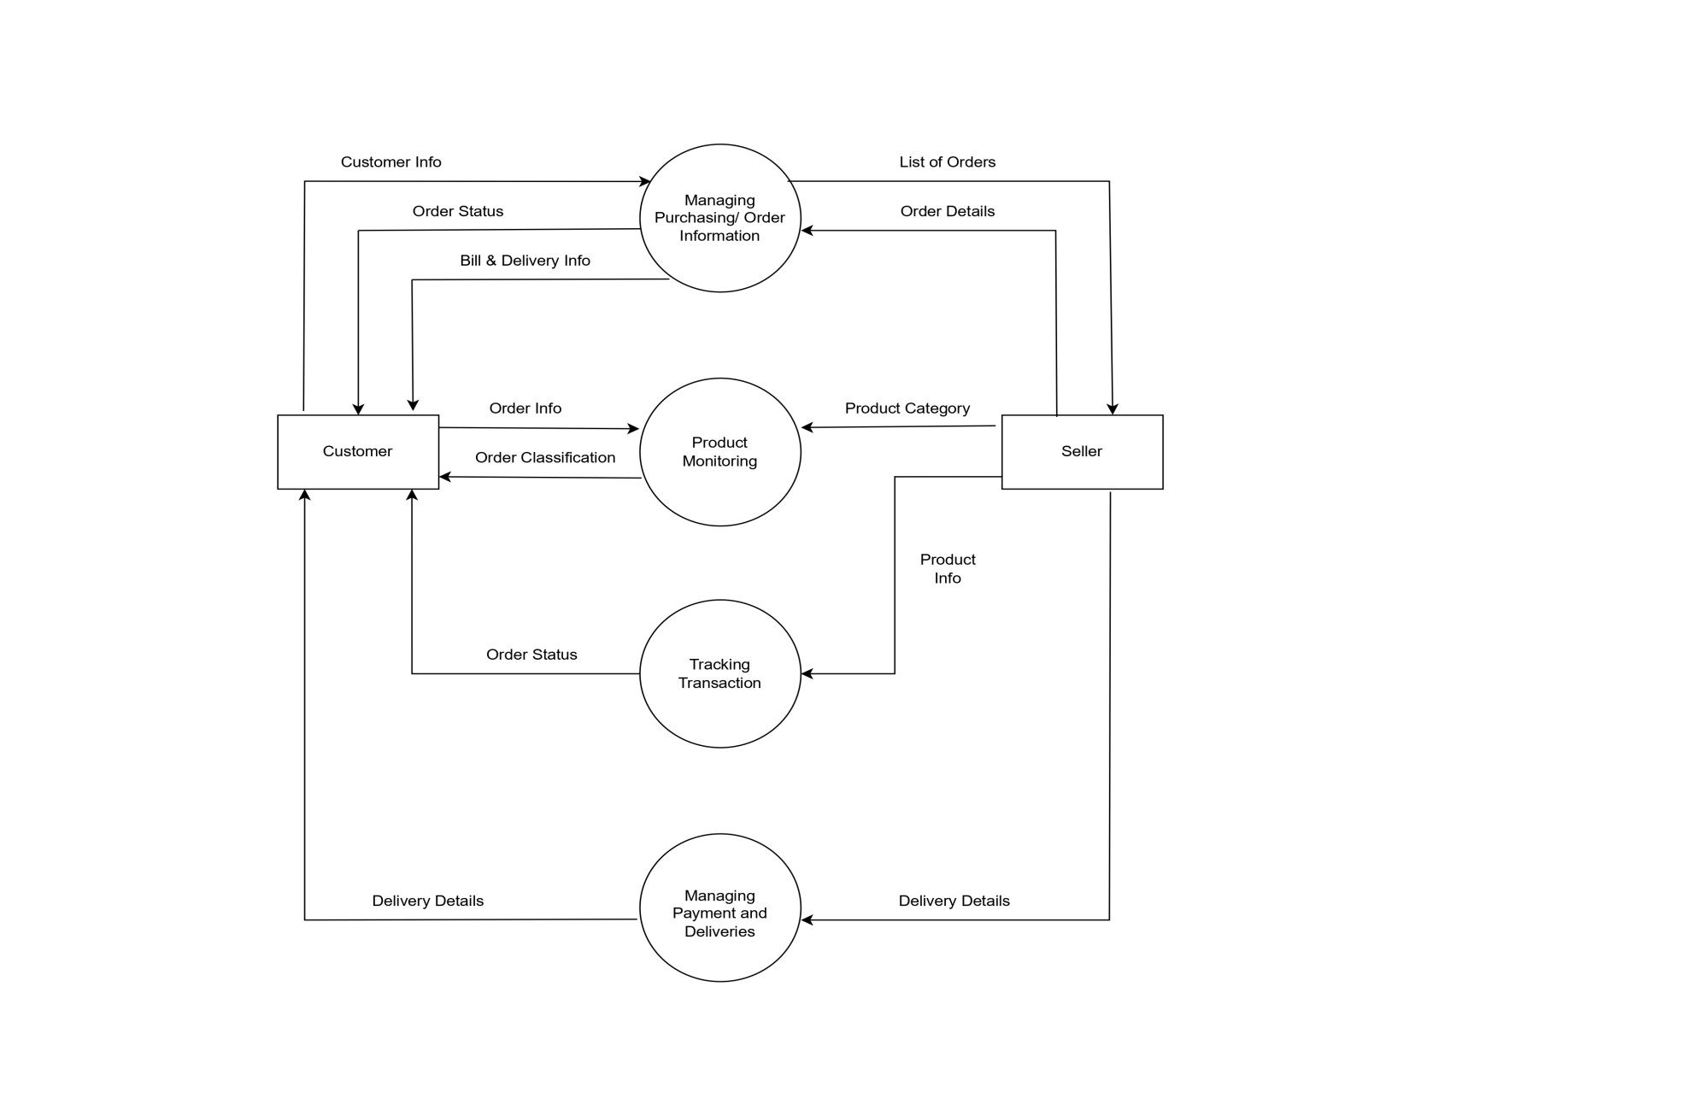**

|  |
| --- |
| **DFD Level 1** |

|  |
| --- |
| **DFD Level 2** |
|  |

**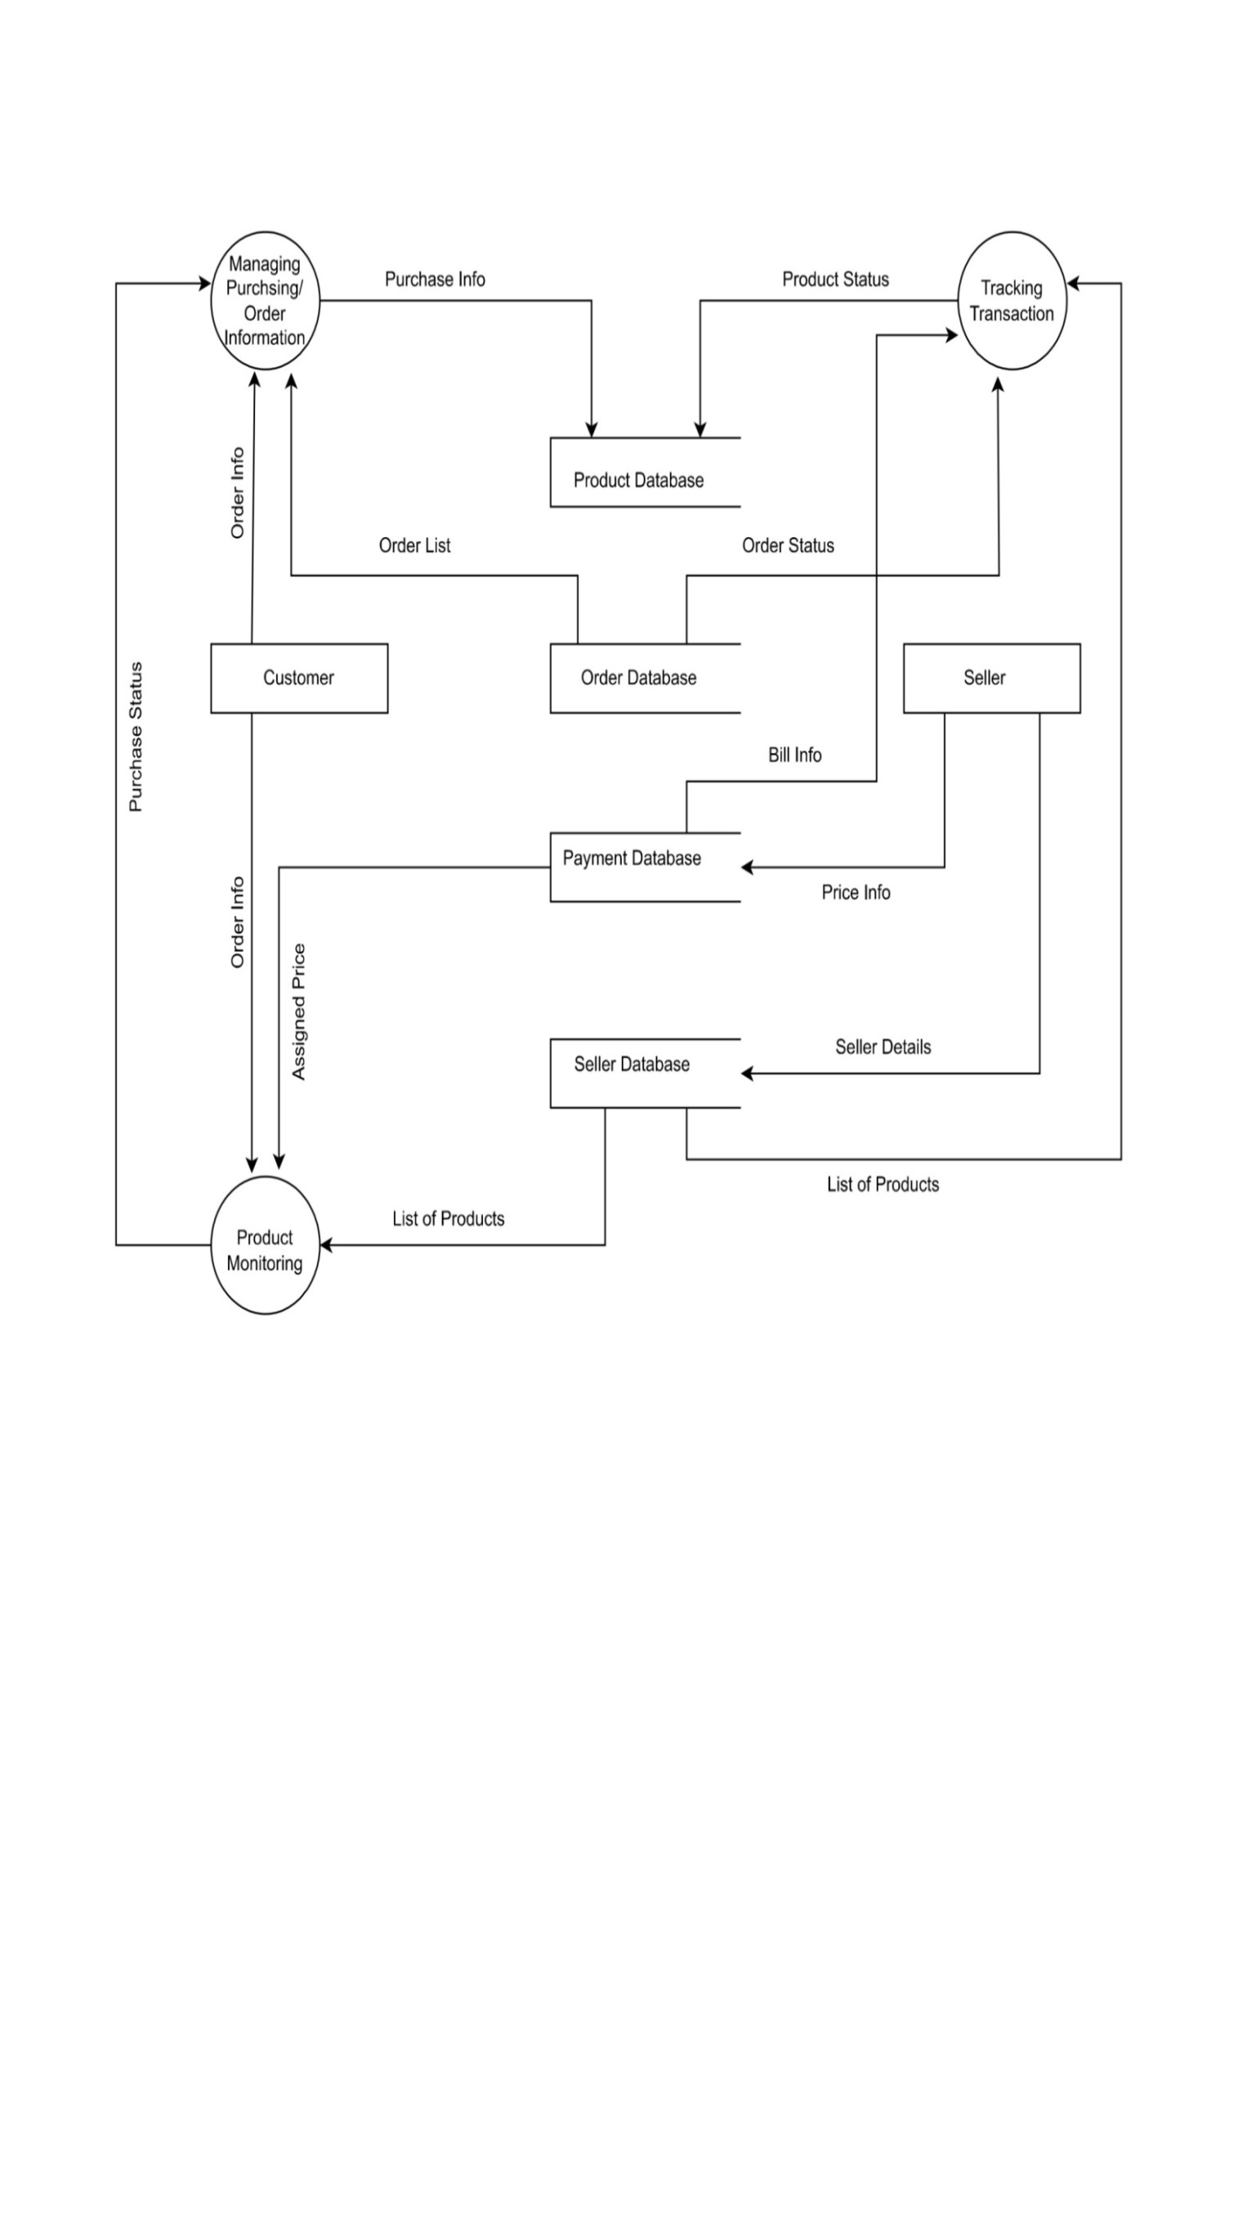**

**4.4 Use Case Diagram**

**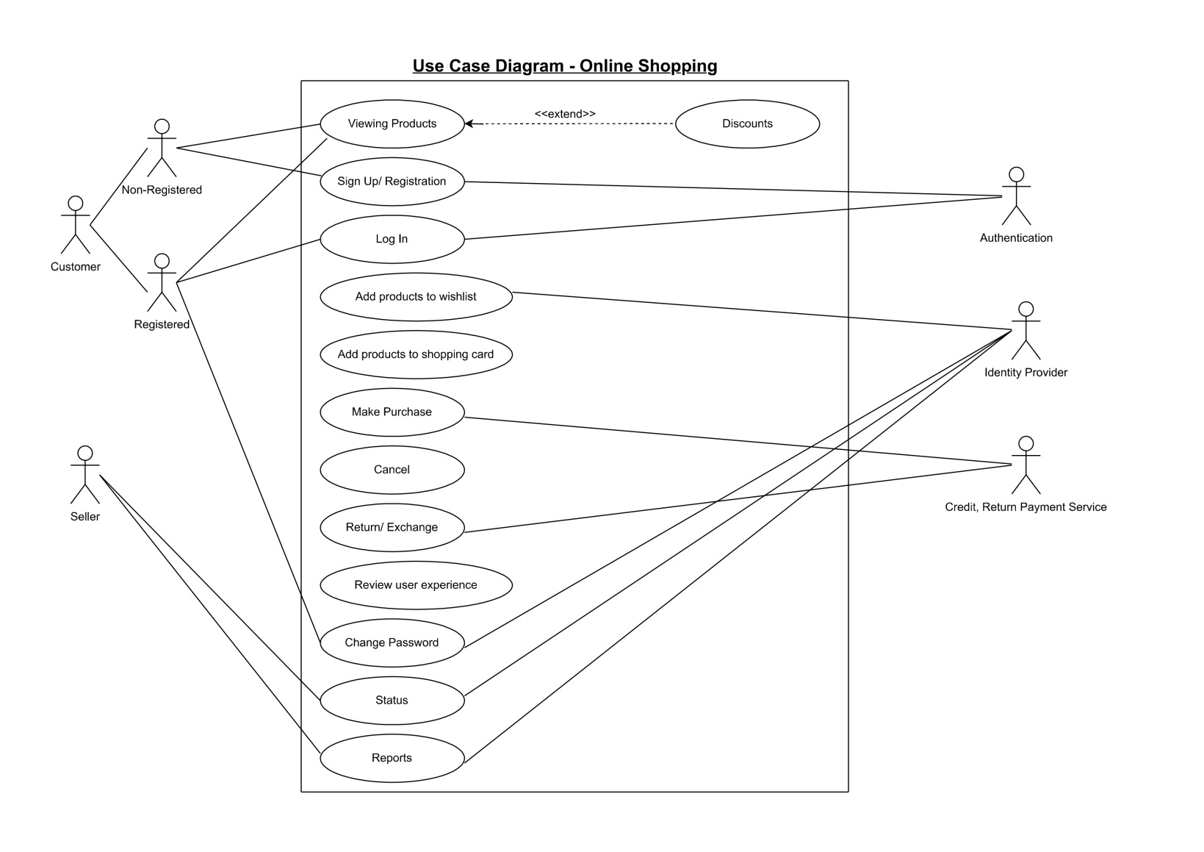**

**4.5. Software requirements**

* + **Front End**
* **HTML**
* **CSS**
* **Java Script**
  + **Back End**
* **XAMPP Control Panel v3.3.2**

# Front end

##### It has basically home page, index page, contact page, product details page, cart details page etc. using HTML CSS JavaScript and Bootstrap 5.

# Middle end

##### In middle end the connect.php file is used to connect the php files with the database server.

##### Database Server

XAMPP is among the simple light-weight local servers for website development.

**Requirements:** XAMPP web server procedure:

* Start XAMPP server by starting Apache and MySQL.
* Write PHP script for connecting to XAMPP.
* Run it in the local browser.

Database is successfully created which is based on the PHP code.

##### 

|  |
| --- |
| Product Table |

|  |
| --- |
| **Signup Table** |

**4.5.6** **Hardware Requirements**

* 32.bit OS
* 4GB RAM,
* Intel i-core 3rd generation

**5. SYSTEM DESIGN**

* 1. **HOME PAGE**

The Home Page of our website consists of navigation bar, sliding images showing current offers and discounts available now and different kinds of electronic products.

**Home Page**

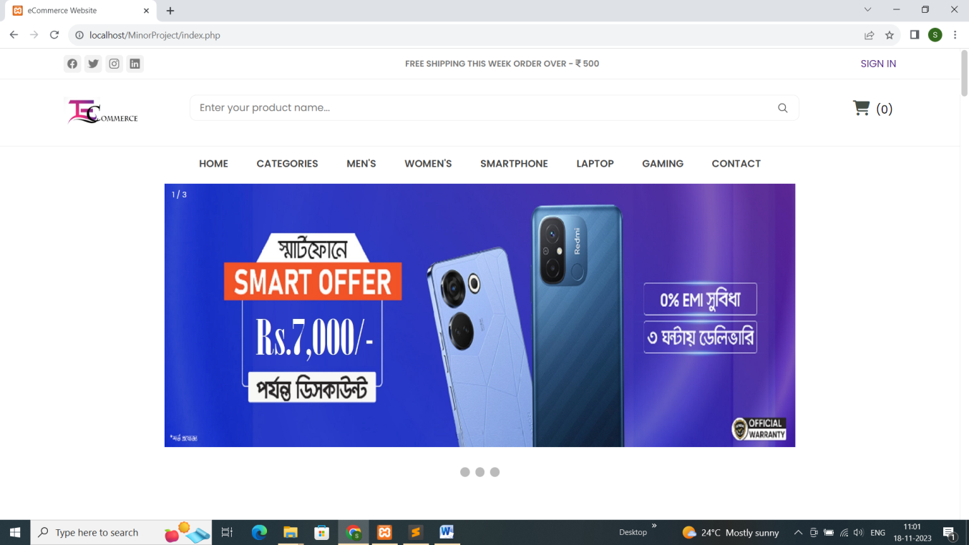

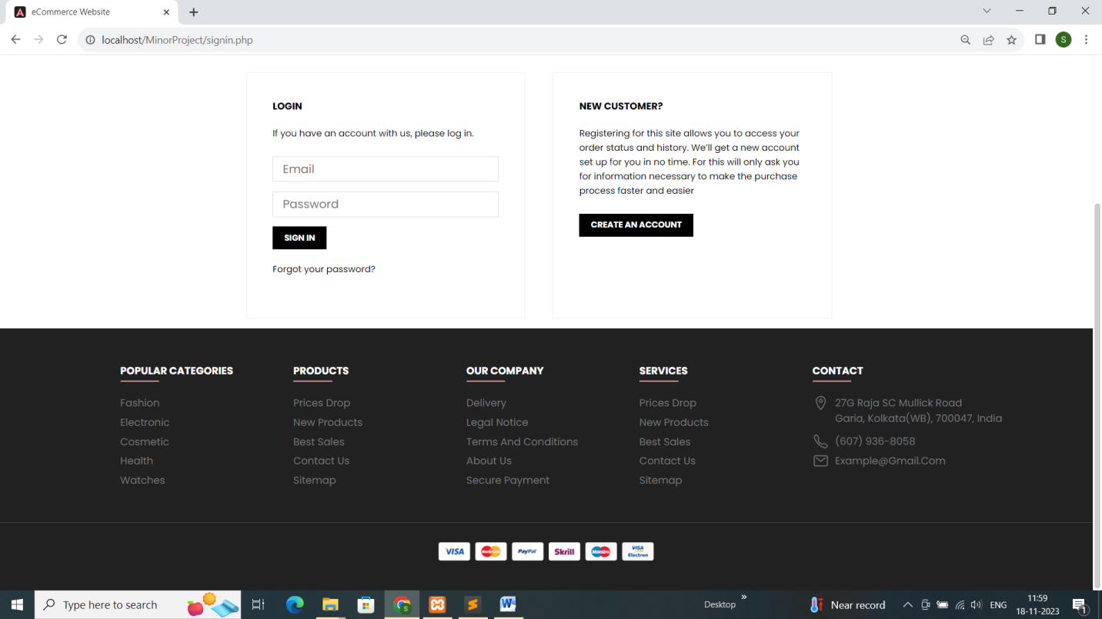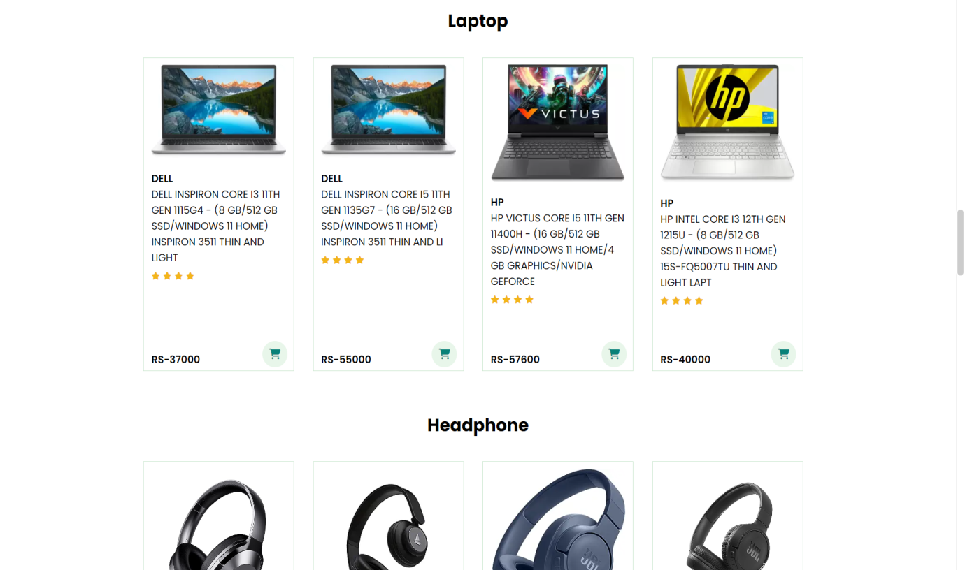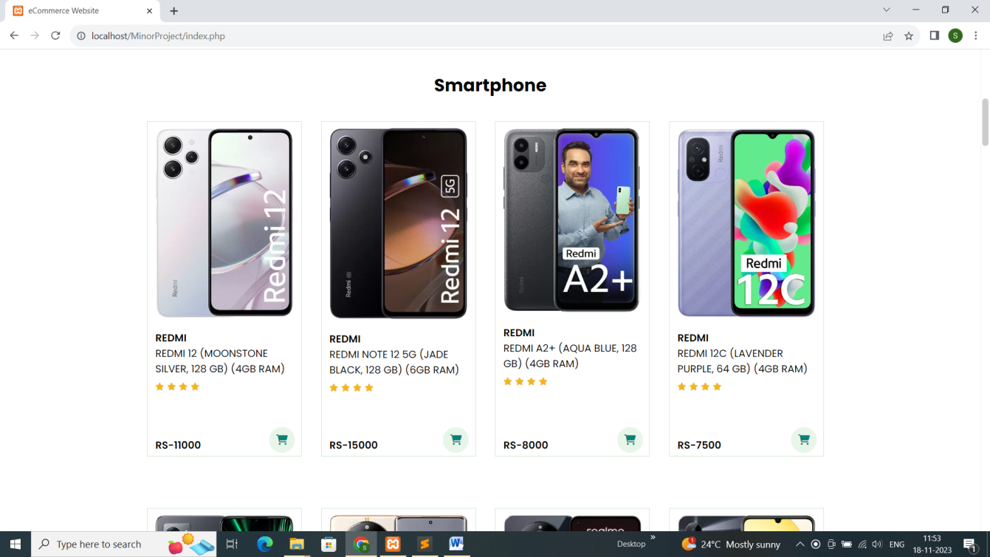

**5.2 Signup Page**

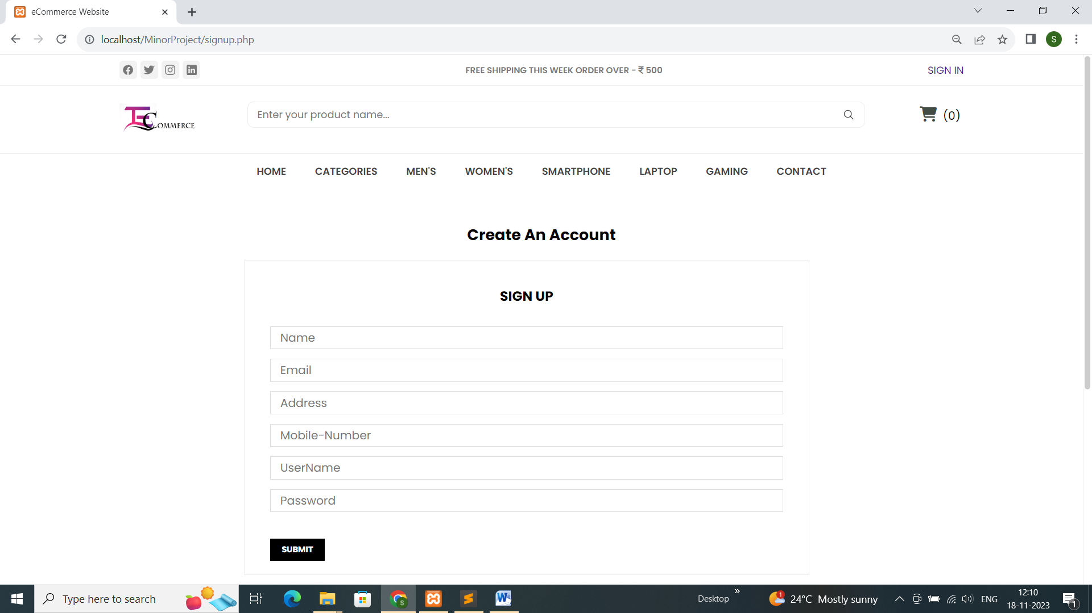



5.3 **Login Page**

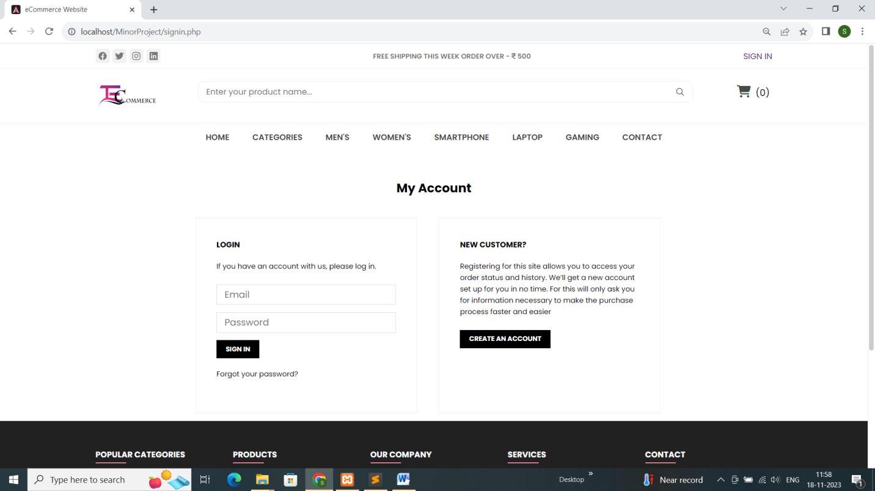

# 5.4 Product Details Page

# The product details page shows detailed information about the product.

# 

# 

# 5.5. Contact Page

# 



# 6. CODING

# 6.1 FEATURES OF LANGUAGE

* Simplicity: - PHP is particularly famous for its simplicity. It is organized and easy to learn.

Even beginners won’t face any hard time learning and using PHP. It is a very well-organized programming language, and it comes with a lot of pre-defined functions, which makes the task

of the programmer easy. There is no need to include libraries in PHP like C. With a lot of

pre-defined functions, PHP is easy to optimize as well.

* Flexibility: - PHP scripts can run on any device- mobile, tablet, or PC. It is very compatible with various databases. It can be easily embedded and integrated into HTML, XML, and JavaScript. Likewise, it is also compatible with almost all servers used today like Apache, IIS, etc.
* Objective oriented: - PHP supports object-oriented programming features like data encapsulation, inheritance, abstraction, polymorphism, etc. The Object-oriented programming feature was added in PHP5. This feature helps in building complex reusable web pages and makes PHP comparable to powerful object-oriented languages like Java and Python.
* Interpreted language: - PHP is an interpreted language, which means there is no need for compilation. Interpreters run through a program line by line and execute the code. Since interpreters execute source code themselves, the code becomes platform-independent. Some other benefits of interpreted language include dynamic typing and short executable program size.
* Efficient: - PHP is a versatile, reliable, and efficient programming language. The memory management of PHP is very efficient. Great session management, eliminating unnecessary memory allocation, are some of the features that make PHP efficient.
* Fast Performance: - PHP scrips are usually faster than other scripting languages. Users can load their web pages faster, and they love it. PHP code runs faster than most of programming languages because it runs in its own memory space. Not only that, but its connection with databases is also fast and efficient.
* Free and open-source: - PHP is open-source, which means it can be downloaded and used freely. There is absolutely no hassle to acquire a license to use it and no payment is required to use it, so it is kind to your pocket too.
* Case-sensitive: - PHP is a partially case-sensitive language. Although functions names are not case-sensitive, other things in PHP are case-sensitive. The following things in PHP are case-sensitive:

Variable names

Constructs (if, if-else, if-elseif, while, do-while)

Keywords (such as true and false)

User-defined functions and class names

* Platform independent: We can run PHP on any device and operating system (Microsoft Windows, macOS, Linux, RISC OS, or Unix). We can easily connect it with various databases and is also compatible with almost all web servers used today (Apache, IIS, and others). It supports a wide range of databases as well. Its cross-platform compatibility makes really popular among its users as it saves a lot of time and energy.

**Home Page: index.php**

<!DOCTYPE html>

<html lang="en">

<head>

  <meta charset="UTF-8">

  <meta http-equiv="X-UA-Compatible" content="IE=edge">

  <meta name="viewport" content="width=device-width, initial-scale=1.0">

  <title>eCommerce Website</title>

  <!--

    - favicon

  -->

 <!--  <link rel="shortcut icon" href="./assets/images/logo/favicon.ico" type="image/x-icon"> -->

  <!--

    - custom css link

  -->

  <link rel="stylesheet" href="style.css">

  <!--

    - google font link

  -->

  <link rel="preconnect" href="https://fonts.googleapis.com">

  <link rel="preconnect" href="https://fonts.gstatic.com" crossorigin>

  <link href="https://fonts.googleapis.com/css2?family=Poppins:wght@300;400;500;600;700;800;900&display=swap"

    rel="stylesheet">

  <link rel="stylesheet" type="text/css" href="https://cdnjs.cloudflare.com/ajax/libs/font-awesome/6.4.2/css/all.min.css">

<style>

  #single1 {

  text-align:center;

  }

  #single1 .product{

  width: 22%;

  min-width: 240px;

  padding:10px 12px;

  border: 1px solid #cce7d0;

  margin:25px 0;

  /\* height: 450px; \*/

  position: relative;

  }

  #single1 .product img {

    width: 100%;

    border-radius:10px;

  }

  #single1 .product-container {

    display:flex;

    max-width: 70%;

    margin:10px auto;

    flex-wrap:wrap;

    /\* justify-content:space-around; \*/

    gap:30px;

  }

  #single1 .product .des{

    text-align:start;

    padding:10px 0;

  }

  #single1 .product .des h2{

    color: var(--eerie-black);

    font-size: var(--fs-7);

    font-weight: var(--weight-600);

    text-transform: uppercase;

  }

  #single1 .product .des span{

    color:#6066063;

    font-size:12px;

  }

/\*  #single1 .product .des h5{

    padding-top:7px;

    color:#1a1a1a;

    font-size:14px;

  }\*/

  #single1 .product .des i{

    font-size:12px;

    color :rgb(243, 181, 25);

    margin-bottom:80px;

  }

#single1 .product .des h4{

    padding-top:7px;

    font-size:15px;

    font-weight:700;

    color:#088178;

    position:absolute;

    bottom:20px;

  }

  #single1 .product .cart{

    width: 40px;

    height: 40px;

    line-height:40px;

    border-radius:50px;

    background-color:#e8f6ea;

    /\* font-weight:500; \*/

    color:#088178;

    position: absolute;

    bottom:5px;

    right:10px;

  }

</style>

</head>

<body>

<!-- Product -->

<?php

include 'navbar.php';

?>

<!--  -Carousel- -->

 <!-- Banner -->

  <div class="slideshow-container">

    <div class="mySlides fade">

      <div class="numbertext">1 / 3</div>

      <img src="./assets/images/banner-4.jpg" style="width:100%">

      <!-- <div class="b1">Caption Text</div> -->

    </div>

    <div class="mySlides fade">

      <div class="numbertext">2 / 3</div>

      <img src="./assets/images/banner-5.jpg" style="width:100%">

      <!-- <div class="b1">Caption Two</div> -->

    </div>

    <div class="mySlides fade">

      <div class="numbertext">3 / 3</div>

      <img src="./assets/images/banner-6.jpeg" style="width:100%">

      <!-- <div class="b1">Caption Two</div> -->

    </div>

</div>

    <br>

    <div style="text-align:center">

      <span class="dot"></span>

      <span class="dot"></span>

      <span class="dot"></span>

    </div>

  </div>

    <br><br>

<!-- Cart Section -->

<section id="single1" class="section-p1">

<!-- Smartphone -->

 <div class="headline text-center">

  <h2>Smartphone</h2>

 </div>

  <div class="product-container product-list">

      <?php

                $sql= "select \* from product where Category='Smartphone' ";

                $r= mysqli\_query($con,$sql);

                while ($row=mysqli\_fetch\_assoc($r))

                    {

                          ?>

    <div class="product">

      <img src="Admin/<?php echo $row['Image']; ?>" alt="" class="product-img">

      <div class="des">

        <h2><a style="color: black;" href="productdetails.php?id=<?php echo $row['ID']?>" ><?php echo $row['Description']; ?></a></h2>

        <h2><a style="color: black;font-weight: 400;" class="product-title" href="productdetails.php?id=<?php echo $row['ID']?>" ><?php echo $row['Name']; ?></a></h2>

          <div class="star">

            <i class="fas fa-star"></i>

            <i class="fas fa-star"></i>

            <i class="fas fa-star"></i>

            <i class="fas fa-star"></i>

          </div>

        <h2 class="product-title rp" style="color: black;font-weight: 550;">Rs-<?php echo $row['SP']; ?></h2>

      </div> <!-- des close -->

      <a href="productdetails.php?id=<?php echo $row['ID']?>" ><i class="fa-solid fa-cart-shopping cart"></i></a>

    </div> <!-- pro close -->

 <?php

                    }

                            ?>

    </div> <!-- product-list close -->

<br>

<!-- Laptop -->

 <div class="headline text-center">

  <h2>Laptop</h2>

 </div>

  <div class="product-container product-list">

      <?php

                $sql= "select \* from product where Category='Laptop' ";

                $r= mysqli\_query($con,$sql);

                while ($row=mysqli\_fetch\_assoc($r))

                    {

                          ?>

    <div class="product">

      <img src="Admin/<?php echo $row['Image']; ?>" alt="" class="product-img">

      <div class="des">

        <h2 class="product-title"><a style="color: black;" href="productdetails.php?id=<?php echo $row['ID']?>" ><?php echo $row['Description']; ?></a></h2>

        <h2><a style="color: black;font-weight: 400;" class="product-title" href="productdetails.php?id=<?php echo $row['ID']?>" ><?php echo $row['Name']; ?></a></h2>

          <div class="star">

            <i class="fas fa-star"></i>

            <i class="fas fa-star"></i>

            <i class="fas fa-star"></i>

            <i class="fas fa-star"></i>

          </div>

        <h2 class="product-title rp" style="color: black;font-weight: 550;">Rs-<?php echo $row['SP']; ?></h2>

      </div> <!-- des close -->

      <a href="productdetails.php?id=<?php echo $row['ID']?>" ><i class="fa-solid fa-cart-shopping cart"></i></a>

    </div> <!-- pro close -->

        <?php

                    }

                            ?>

    </div> <!-- product-list close --><br>

</section>

  <br>  <!-- Footer -->

<?php

include 'footer.php';

?>

  <!--

    - custom js link

  -->

  <script src="script.js"></script>

<script type="module" src="https://unpkg.com/ionicons@5.5.2/dist/ionicons/ionicons.esm.js"></script>

  <script nomodule src="https://unpkg.com/ionicons@5.5.2/dist/ionicons/ionicons.js"></script>

</body>

</html>

**Signup Page: signup.php**

<!-- signup-section -->

<h1 class="page-title text-center">Create An Account</h1>

<div class="page-width" >

    <div class="flex login-register">

        <div class="flex-item-l">

            <div class="wrap" style="margin-top: -2%">

                <center><h3 style="margin-bottom: 4%;">SIGN UP</h3></center>

                <div id="CustomerLoginForm" class="form-vertical">

                    <form method="post" action="u1.php">

<input type="text" placeholder="Name"  autofocus="" name="t1" style="height: 36px;">

<input type="email" name="t2" placeholder="Email"id="CustomerEmail"  style="height: 36px;">

  <input type="text" placeholder="Address" id="" name="t3" style="height: 36px;">

 <input type="text" name="t4" placeholder="Mobile-Number" pattern="[0-9]{3}[0-9]{3}[0-9]{4}" style="height: 36px;">

<input type="text" name="t5" placeholder="UserName" style="height: 36px;">

                     <input type="password" name="t6" placeholder="Password" id="CustomerPassword" class="" style="height: 36px;"><br>

                     <div class="text-center hover-line">

                     <button type="submit" class="btn2" value="Submit">

                      Submit

                     </div>

                  </form>

             </div>

            </div>

        </div>

    </div><br><br>

</div>

**Login Page: signin.php**

<!-- login-section -->

<h1 class="page-title text-center">My Account</h1>

<div class="page-width">

    <div class="flex login-register">

        <div class="flex-item-l">

            <div class="wrap">

                <h5>LOGIN</h5>

                <p>If you have an account with us, please log in.</p>

                <div id="CustomerLoginForm" class="form-vertical">

                <form method="post" action="session.php">

                     <input type="text" name="t1" placeholder="User-ID" id="CustomerEmail" class="">

                     <input type="password" value="" name="t2" placeholder="Password" id="CustomerPassword" class="">

                     <div class="text-center hover-line">

                       <button type="submit" class="btn2" >Sign In</button>

                       <p><a href="#recover" id="RecoverPassword" style="color: black;">Forgot your password?</a></p>

                     </div>

                     </form>

             </div>

            </div>

        </div>

        <div class="flex-item-r">

            <div class="wrap">

              <h5>NEW CUSTOMER?</h5>

              <p>Registering for this site allows you to access your order status and history. We’ll get a new account set up for you in no time. For this will only ask you for information necessary to make the purchase process faster and easier</p>

              <a href="signup.php" class="btn2">Create an account</a>

            </div>

          </div>

    </div>

</div>

**Product details Page: productdetails.php**

<?php

include 'navbar.php';

$Id=$\_GET['id'];

$sql= "select \* from product where ID=$Id";

$r= mysqli\_query($con,$sql);

 if($row = mysqli\_fetch\_assoc($r)){

  $name=$row['Name'];

  $dsc= $row['Description'];

  $cat= $row['Category'];

  $rtr= $row['Rating'];

  $cp=  $row['CP'];

  $sp=  $row['SP'];

  $img= $row['Image'];

 }

?>

<!DOCTYPE html>

<html lang="en">

<head>

    <meta charset="UTF-8">

    <meta name="viewport" content="width=device-width, initial-scale=1.0">

    <title>eCommerce Website</title>

    <!--

      - favicon

    -->

    <link rel="shortcut icon" href="./assets/images/logo/favicon.ico" type="image/x-icon">

    <!--

      - custom css link

    -->

    <link rel="stylesheet" href="product\_details.css">

    <!--

      - google font link

    -->

    <link rel="preconnect" href="https://fonts.googleapis.com">

    <link rel="preconnect" href="https://fonts.gstatic.com" crossorigin>

    <link href="https://fonts.googleapis.com/css2?family=Poppins:wght@300;400;500;600;700;800;900&display=swap"

      rel="stylesheet">

    <link rel="stylesheet" href="https://cdnjs.cloudflare.com/ajax/libs/font-awesome/6.4.2/css/all.min.css" integrity="sha512-z3gLpd7yknf1YoNbCzqRKc4qyor8gaKU1qmn+CShxbuBusANI9QpRohGBreCFkKxLhei6S9CQXFEbbKuqLg0DA==" crossorigin="anonymous" referrerpolicy="no-referrer" />

</head>

<body>

**Show Cart Page: showcart.php**

<div class="small-container cart-page">

<?php

                if (!empty($\_SESSION['cart\_info'])) {

                $len=sizeof($\_SESSION['cart\_info']);

                $sum=0;

            ?>

<div class="table1">

<table class="gh">

    <tr>

        <th>Serial no</th>

        <th>Product</th>

        <th>Quantity</th>

        <th>Price</th>

        <th>Subtotal</th>

    </tr>

    <?php

                    for ($i=0; $i<$len; $i++)

                    {

                    $sum+=$\_SESSION['cart\_info'][$i]['total'];

                    $sr=$i+1;

                  ?>

    <tr>

        <td><?php echo"$sr"?></td>

        <td>

            <div class="cart-in">

                <img src="Admin/<?php echo $\_SESSION['cart\_info'][$i]['image'] ?>">

                <div>

                    <p><?php echo $\_SESSION['cart\_info'][$i]['pname'];?></p>

                    <a href="remove.php?index=<?php echo $i; ?>">remove</a>

                </div>

            </div>

        </td>

        <td><?php echo $\_SESSION['cart\_info'][$i]['qty'];?></td>

        <td><?php echo $\_SESSION['cart\_info'][$i]['sprice'];?></td>

        <td><?php echo $\_SESSION['cart\_info'][$i]['total']; ?></td>

    </tr>

    <?php

                    }

    ?>

</table>

</div>

    <div class="table2">

    <table class="gj">

        <tr>

            <td>Gross Total</td>

            <?php $\_SESSION['total\_amt']=$sum;?>

            <td><?php echo $sum; ?></td>

        </tr>

    </table>

    </div>

    </div>

<div class="button">

<a href="Paymentcheck.php" class="button1">Proceed to pay</a>

        <?php }

        else{

            ?>

            <span class="empty"><img src="./Admin/IMG/empty.png"></span>

            <?php

        } ?>

</div>

**Contact Page: contact.php**

<?php

include 'navbar.php';

?>

<!DOCTYPE html>

<html>

<head>

  <title></title>

<link rel="stylesheet" href="login.css">

</head>

<body>

<center>

<div style="max-width: 868px;padding: 20px;">

  <div style="text-align: left;">

    <div>

    <center><span style="font-family:Times New Roman, Georgia, Serif;font-size: 27px;color: black;margin-top: 5%;"><b>CONTACT US</b></span></center>

    <br><br>

    <p style="justify-content: left; font-family:Times New Roman, Georgia, Serif;font-size: 18px;">You can also contact us by phone <b>8420158140</b> or email <b>ecommercekolkata@gmail.com</b>, or you can send us a message here:</p><br>

    <p style=" font-family:Times New Roman, Georgia, Serif;font-size: 20px;color: black;">

      <i class="fa-solid fa-location-dot" style="color: green;"></i>&nbsp;27G Raja SC Mullick Road Garia, Kolkata(WB), 700047</p><br>

   <form action="" method="post">

      <p><input type="text" placeholder="Name" style=" font-size: 16px;height: 40px;"></p><br>

      <p><input type="text" placeholder="Enter your email-id" style=" font-size: 16px;height: 40px;"></p><br>

      <!-- <p><input  class="form-control" type="text"  required="" name="msg"></p><br> -->

      <p><textarea rows="5" cols="45" placeholder="Message \ Special requirements" placeholder="Enter your email-id" style=" font-size: 16px;"></textarea></p><br>

      <p>

        <!-- <button class="main-btn" type="submit" style="max-width: 200px;font-size: 16px;">SEND MESSAGE</button> -->

        <button type="submit" class="btn2" style="height: 40px;font-size: 14px;">SEND MESSAGE</button>

      </p>

    </form>

</div></div>

</center><br><br>

<?php

include 'footer.php';

?>

</body>

</html>

**Billing Page: addtocart.php**

<?php

    include 'navbar.php';

    $Id=$\_GET['id'];

    $Qty=$\_GET['quantity'];

    // echo $Id."<br>";

    // echo $Qty;

    $sql="select \* from product where ID=$Id";

    $r= mysqli\_query($con,$sql);

    if($row=mysqli\_fetch\_assoc($r)){

    $single=array("pid"=>$Id,"pname"=>$row['Name'],"pdecrip"=>$row['Description'],"pcate"=>$row['Category'],"prating"=>$row['Rating'],"cprice"=>$row['CP'],"sprice"=>$row['SP'],"image"=>$row['Image'],"qty"=>$Qty,"total"=>$row['SP']\*$Qty);

}

if (empty($\_SESSION['cart\_info'])) {

    $\_SESSION['cart\_info']=array($single);

}

else

{

    //searcing

    $flag=0;

    $len=sizeof($\_SESSION['cart\_info']);

    for ($i=0; $i < $len ; $i++)

     {

        if($\_SESSION['cart\_info'][$i]['pid']==$Id)

        {

            $\_SESSION['cart\_info'][$i]['qty']+=$Qty;

            $\_SESSION['cart\_info'][$i]['total']=

            $\_SESSION['cart\_info'][$i]['qty']\*

            $\_SESSION['cart\_info'][$i]['sprice'];

            $flag=1;

        }

    }

    if($flag==0)

    {

        array\_push($\_SESSION['cart\_info'], $single);

    }

}

**Session Page**: **session.php**

<?php

    $Id=$\_POST['t1'];

    $Password=$\_POST['t2'];

    echo $Id."<br>";

    echo $Password;

    include 'connect.php';

    $sql= "select \* from signup where Username = '$Id' and Password = '$Password' ";

    echo $sql;

    $r= mysqli\_query($con,$sql);

    if($row=mysqli\_fetch\_assoc($r)){

$\_SESSION['Username'] = $row['Username'];

$\_SESSION['Name']=$row['Name'];

$\_SESSION['Name']=$row['Name'];

        $\_SESSION['Email']=$row['Email'];

        $\_SESSION['PhoneNo']=$row['PhoneNo'];

        $\_SESSION['Address']=$row['Address'];

        header('location:index.php');

    }

else{

        header('location:signin.php');

    }

?>

1. **EXPERIMENTAL RESULTS**

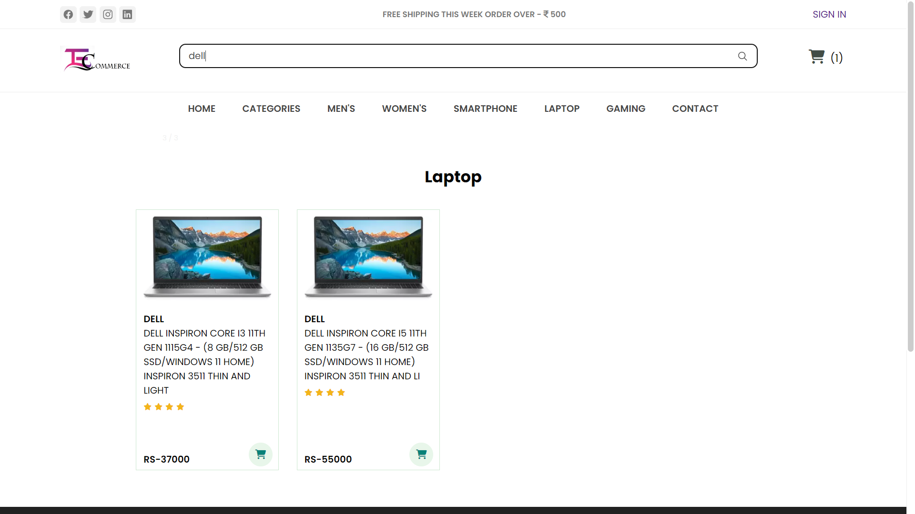

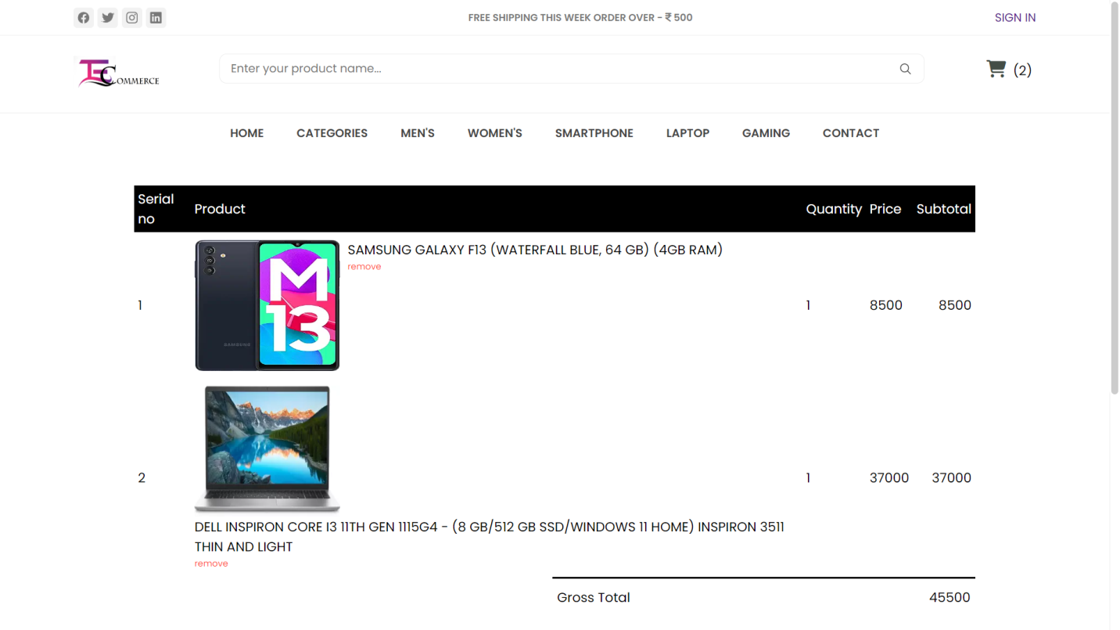

1. **FUTURE SCOPES**

In the strategic roadmap of our E-commerce project, the deliberate postponement of integrating

payment options signifies a purposeful decision. This approach allows us to prioritize foundational

elements, such as user experience and platform stability, in the initial phases. By deferring payment integration, we gain flexibility to adapt to emerging financial technologies and market demands.

This deliberate delay aligns with a phased development strategy, ensuring a methodical and structured implementation process. It also provides the opportunity for comprehensive market research and

analysis to determine the most suitable payment solutions for our target audience.

Ultimately, this strategy aims to craft a robust and adaptable payment system, tailored to meet the

evolving needs of our users while fostering a secure and seamless transactional experience

# CONCLUSION

E-commerce is an ever developing area. With the advancement in technology and communication,

e-commerce has also gained popularity among the people of India and worldwide. It has made

e-business easy and accessible to people sitting at home. E-commerce has a huge impact on costs,

access to goods and services and increased productivity of businesses. It also plays an important

role in the economic growth and development of a nation. Though it is a relatively new area

belonging to the era of the internet, it has the potential to change and replace the traditional form

of business and trade activities.

# ACKNOWLEDGEMENT

### We are thankful to all the people who joined us as a part of making this journey of fulfilling this project into working model. We are grateful to **Future Institute Of Engineering And Management** for giving us a wonderful platform for exploring our software developing skills during the making of this project.

*We also express our heartfelt gratitude to* ***Prof. Shreyasi Bhattacharya*** *our Project Mentor for rendering all possible help and support during the development, implementation and presentation of the project.*

*We are also thankful to our other professors of* ***Computer Application Department f****or their constructive and helpful inputs.*

**10. REFERENCES/BIBLIOGRAPHY**

* <https://www.google.co.in/>
* <https://fontawesome.com/icons>
* <https://getbootstrap.com/docs/5.0/getting-started/introduction/>
* <https://www.w3schools.com/>
* <https://www.wikipedia.org/>